**MGAC02 Case Assignment 2**

**Name: Qian Chen**

**Student ID Number: 1005740548**

**Situational Analysis**

**Overview:** Deermark Ltd. is retail operation traded publicly. And IFRS is required in the financial reports.

**Objectives:** As an auditor, we are required to adjust the income statements including tax provision given the update information to better and more accurately reflect the company’s financial situations and help managers make decisions and plans for future.

**Stakeholders:**

**Managers:** concerning about Deermark operational performance, profitability and sustainability

**Shareholders and potential investor:** concerning about company’s profitability and interested in the financial status

**Constraints:** Given information, IFRS is applied in all financial report of Deermark Ltd.

**Issue 1: Pension Plan**

**Analyze the nature of the issue:** The pension plan was introduced at the beginning of 2024. Through using 7% discount rate for both pension plan obligation and plan asset to recalculate the pension expense, it indicates more expense should be recorded and certain amount of other comprehensive incomes should be incurred in the income statement. The understated expense can lead to the more income tax- estimate, some revisal required to better reflect the real amount.

**Analysis:** According to IAS16 123 “*An entity shall determine net interest on the net defined benefit liability (asset) by multiplying the net defined benefit liability (asset) by the discount rate specified in paragraph*” the discount rate of 7% will be applied in the calculation of interest on DBO as well as expected return. At the same time, under IFRS, pension expense will only include current service cost, past service cost, interest on DBO and expected return, and should be $2500,000.

Given IAS19 122 “*Remeasurements of the net defined benefit liability (asset) recognised in other comprehensive income shall not be reclassified to profit or loss in a subsequent period. However, the entity may transfer those amounts recognised in other comprehensive income within equity.”* The difference between actual return and expected return should be accounted for other comprehensive income. That amount would not be classified as the gain or loss and not affect the tax estimation. Actual interest rate 9% is applied, actual return is $180,000, expected return is $140,000 and the difference is $40,000.

The previous journal entry should be found and updated according to the new calculation result (see table 1). Otherwise, expense and liability will be understated $50000 and $460000 respectively, OCI will be understated $40000. That will influence the estimated tax and opening balance of liability in the next year.

**Issue 2: Repurchase common shares**

**Analyze the nature of the issue:** On February 1,2024, 20,000 of shares are bought back and cancelled by Deermark. Ltd. The company directly recorded this amount as the operating expense, which is not reconcile with the IFRS requirements. There exists overstated operating expense, common shares and retained earnings. And the total number of shares has not been corrected given the income statement, making the earning per shares presented not enough accurate. In addition, the call option is issued and expire in 2025, some related disclosures are required to help stakeholders better understand the company’s financial status and make decisions.

**Analysis:** According to IAS32 33 “*If an entity reacquires its own equity instruments, those instruments ('treasury shares') shall be deducted from equity. No gain or loss shall be recognised in profit or loss on the purchase, sale, issue or cancellation of an entity's own equity instruments. Such treasury shares may be acquired and held by the entity or by other members of the consolidated group. Consideration paid or received shall be recognised directly in equity.”* Deermark Ltd. repurchase 20,000 common shares and determine to retire it. Initially, the amount repurchase should be deducted from equity, which means it will be considered as treasury shares, the contra account of common share. And extra amount will not be the gain or loss during this repurchase process. Consideration paid or received will directly go into the equity. Therefore, Deermark Ltd. should not directly expense repurchase amount. The company needs to debit treasury stock and credit cash in both $1,000,000. Later on, the shares will be cancelled and not reissue again. The difference between the issue price and purchase price will be included in retained earnings. The entire journal entry should be updated in respect to table 2. In addition, given the information, the actual number of common shares reduce to 1980,000 instead of 2000,000. The updated number should be applied in the calculation of earnings per share.

In this case, there will be no any journal entry related to call option recorded. Only when the portion of the share are granted to an employee or the employee forfeit the option, some related journal entry is required. During this process, some compensation expense may incur and affect the net income and tax provision. In addition, at the end of expired date, remaining expired options and exercised options should be recorded.

**Issue 3: lease payment**

**Analyze the nature of the issue:** A new administrative building is leased under contract. The lease will be classified as the capital lease. Deermark Ltd. directly expense the lease payment, which is not in accordance with IFRS requirement, leading to more expense applied. In addition, the interest expense is recalculated given the discount rate, it presents that interest expense is overstated as well. Likewise, the ownership of the building would be transferred at the end of lease term, indicating the requirement for lessee to amortize the asset. The depreciation incur would be used to compare with CCA to recalculate the taxable income and determine tax provision.

**Analysis:** according to IFRS16 37 *“Interest on the lease liability in each period during the lease term shall be the amount that produces a constant periodic rate of interest on the remaining balance of the lease liability. The periodic rate of interest is the discount rate described in paragraph [26](javascript:document.k5doc.loadDocumentByGotoString(1,%20'IFRS%2016.26',%200,%20null,%20false,%20220533910)), or if applicable the revised discount rate described in paragraph [41](https://edu-knotia-ca.myaccess.library.utoronto.ca/knowledge/Home.aspx?productid=1), paragraph [43](https://edu-knotia-ca.myaccess.library.utoronto.ca/knowledge/Home.aspx?productid=1) or paragraph [45](javascript:document.k5doc.loadDocumentByGotoString(1,%20'IFRS%2016.45',%200,%20null,%20false,%20220533910))(c).”* a constant periodic rate of interest which is the discount rate 7% in this case, should be applied to calculate the interest expense. The result shows that there should be $1890,000 instead of $2450,000 recorded.

According IFRS16 25 “*A lessee shall recognise the costs described in paragraph [24](https://edu-knotia-ca.myaccess.library.utoronto.ca/knowledge/Home.aspx?productid=1)(d) as part of the cost of the right-of-use asset when it incurs an obligation for those costs. A lessee applies [IAS 2](https://edu-knotia-ca.myaccess.library.utoronto.ca/knowledge/Home.aspx?productid=1) Inventories to costs that are incurred during a particular period as a consequence of having used the right-of-use asset to produce inventories during that period. The obligations for such costs accounted for applying this Standard or IAS 2 are recognised and measured applying [IAS 37](https://edu-knotia-ca.myaccess.library.utoronto.ca/knowledge/Home.aspx?productid=1) Provisions, Contingent Liabilities and Contingent Assets.” And in IFRS 16 24 (b) The cost of the right-of-use asset shall comprise:* *(b) any lease payments made at or before the commencement date, less any lease incentives received*;” In this case, the present value of lease payment should be categorized as lease obligation. And any incurred lease payment should be regarded as the exercise of the obligation. The journal entry should be debit lease liability and credit cash instead of directly expense.

On the other hand, according to IFRS16 5 *A lessee may elect not to apply the requirements in paragraphs [22](https://edu-knotia-ca.myaccess.library.utoronto.ca/knowledge/Home.aspx?productid=1)–49 to:* *(a) short-term leases; and* *(b) leases for which the underlying asset is of low value (as described in paragraphs [B3](javascript:document.k5doc.loadDocumentByGotoString(1,%20'IFRS%2016.B3',%200,%20null,%20false,%20220533910))–B8).* And IFRS 6 “*If a lessee elects not to apply the requirements in paragraphs [22](https://edu-knotia-ca.myaccess.library.utoronto.ca/knowledge/Home.aspx?productid=1)–49 to either short-term leases or leases for which the underlying asset is of low value, the lessee shall recognise the lease payments associated with those leases as an expense on either a straight-line basis over the lease term or another systematic basis. The lessee shall apply another systematic basis if that basis is more representative of the pattern of the lessee's benefit*” In this case, the lease payment will not obey the requirements of 25 and 24 mentioned above when one of the two criteria is met, low value or short term lease. Given the information, the lease term is 20 years and the fair value of the building is $30 millions. It is apparently that none of them are met. Thus, the lease payment should not be recorded as the expense incurred. Otherwise, there appear to overstated expense of $3560,000 and overstated $3560,000 lease liability, leading understated tax estimation and overstated opening balance of liability in the next year. The related journal entry should be found and modified according to the new calculation (see table 3).

What’s more, according to IFRS16 32 *“If the lease transfers ownership of the underlying asset to the lessee by the end of the lease term or if the cost of the right-of-use asset reflects that the lessee will exercise a purchase option, the lessee shall depreciate the right-of-use asset from the commencement date to the end of the useful life of the underlying asset. Otherwise, the lessee shall depreciate the right-of-use asset from the commencement date to the earlier of the end of the useful life of the right-of-use asset or the end of the lease term.*” The ownership will be transferred at the end of the 20-year lease for a nominal amount. The lessee is required to amortize the right- of- use asset from the commence date to the end of the useful life, which is 25 years. In this case, no related journal entry is mentioned. For revisal, Deermark Ltd. should debit depreciation expense and credit accumulated depreciation both $1200,000. And under IFRS 16, the right-of-use asset should be also treated as the intangible asset. That indicates asset should be revalued in accordance with the revaluation model, any gains or losses should be recognized, and asset also be considered for impairment. The depreciation expense considered as temporary difference plays the important role in calculation of tax provision.

**Issue 4: tax provision**

**Analyze the nature of the issue:** After the revisal of several journal entry, the total book value of the net income will be affected, leading to the taxable income changed. According to the CCA given, which is $2 million higher than original depreciation expense, equal to $ 8M, the tax provision is needed to evaluate the company’s tax situation.

**Analysis:** The depreciation expense is understated $1200,000 after modification of journal entry in the issue 3. And the pension expense should be $2500,000 instead of $2000,000. While, the operation expense will be affected by repurchase shares (overstated $1000,000), Interest expense of lease asset (overstated $560,000) and lease expense (overstated $3,000,000). Total influence on the expense is overstated $2860,000. Furthermore, the net income presented as understated $2860,000 and estimated tax understate $858,000 (adjusted income statement in table 4). In addition, total shares would be 1980,000 rather than 2000,000 since the retirement of shares. The earnings per share will also be affected by both the change of net income and number of shares.

According to the information, distribution is the only one permanent difference between book value net income and taxable net income. And the temporary difference incurred is the difference between depreciation expense and CCA (calculation given by table 5). *As IAS12 46 “Current tax liabilities (assets) for the current and prior periods shall be measured at the amount expected to be paid to (recovered from) the taxation authorities, using the tax rates (and tax laws) that have been enacted or substantively enacted by the end of the reporting period.”*The current tax rate of 30% should be applied, and the final tax is $4218,000.

**Issue 5: Disclosure**

**Analysis:** Even though no any journal entry of call option issuance recorded, *Given IFRS2 44 “An entity shall disclose information that enables users of the financial statements to understand the nature and extent of share-based payment arrangements that existed during the period.*” the disclosure of this call option related information as well as the information regarding repurchase including remaining numbers and value, is required to help user better understand the nature and extent of share-based payment.

And given “*IAS1 117 An entity shall disclose its significant accounting policies comprising: (a) the measurement basis (or bases) used in preparing the financial statements; and (b) the other accounting policies used that are relevant to an understanding of the financial statements*.”

During the amortization process, the straight-line method was applied since it can allocate an even amount to each accounting period over the asset’s useful life and is easy for calculation and understand. In addition, under the *IFRS16 37* mentioned above, the effective interest rate method is applied during the process.

*“IAS 19 135 An entity shall disclose information that: (a) explains the characteristics of its defined benefit plans and risks associated with them (see paragraph 139); (b) identifies and explains the amounts in its financial statements arising from its defined benefit plans (see paragraphs 140–144); and (c) describes how its defined benefit plans may affect the amount, timing and uncertainty of the entity's future cash flows (see paragraphs 145–147).”* Any potential risk and uncertainty related to pension plan is required. The changed amount due to defined benefit plans is required in the disclosure.

**Disclosure Notes**

**1. Pension Plan**

Total $2000,000 is contributed to the pension plan. The discount 7% is applied in the interest calculation. $2500,000 pension expense incurred this year. And net defined benefit liability is $460,000. There is also $40000 other comprehensive due to the difference between expected return and actual return.

**2. Right-of-use-assets**

Currently, Deermark Ltd. only has the one right of use asset, the building leased this year. The net book value incurred is $30,000,000. The ownership of the asset will be transferred at the end of the lease term. The straight -line method is applied to amortize the right-of-use-assets. For the year end of 2024, the amount of accumulated depreciation is $1200,000. And the depreciation expense incurred is $1200,000 as well. The estimated discounted rate of 7% is applied for incurred interest expense, $1890,000.

**3. Share-based transaction**

On February 1, 2024, the company use $1,000,000 to repurchase 200,000 common shares. The net number of common shares currently is 1980,000 and net value is $19800,000. In addition, call option is issued allowing to purchase 40,000 shares for $ 40 per share, expiring in 2025.

**Appendix**

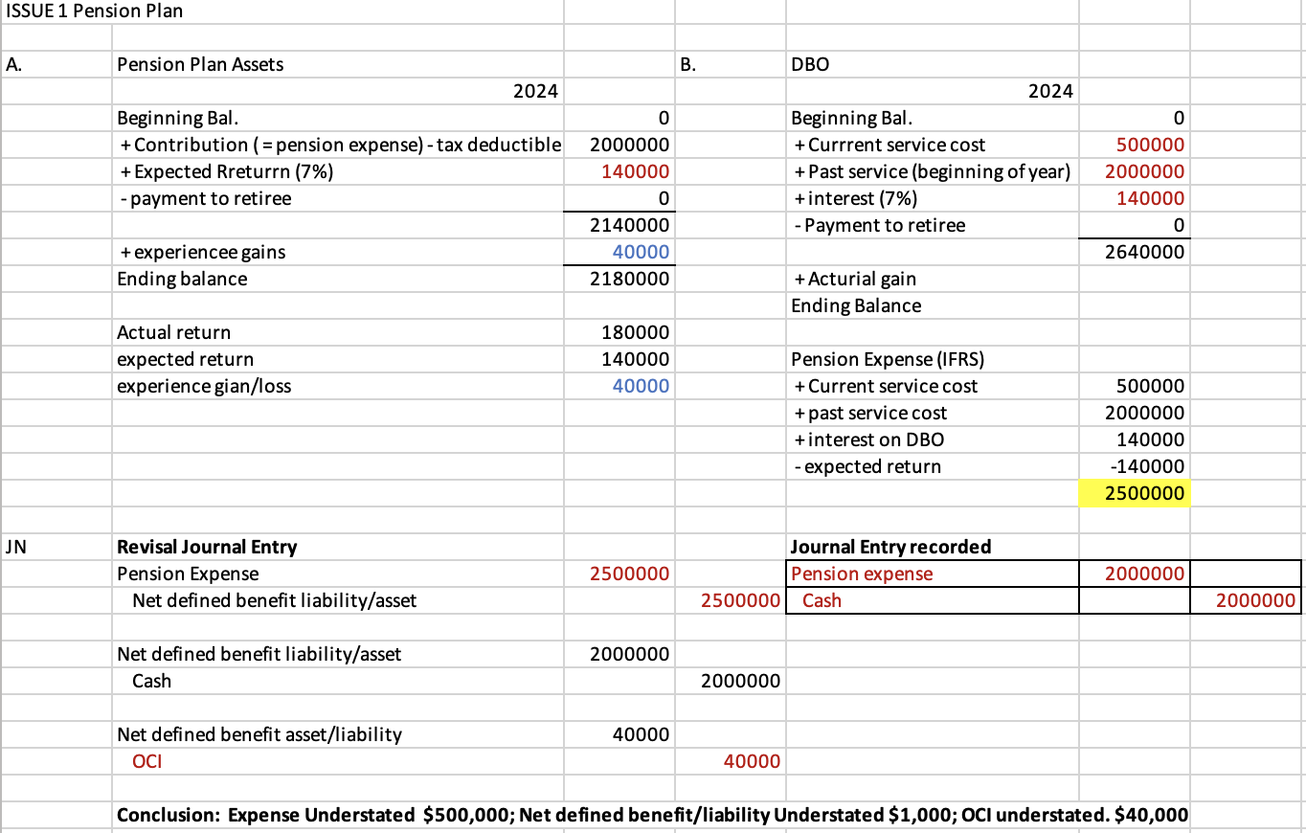

**(Table 1)**

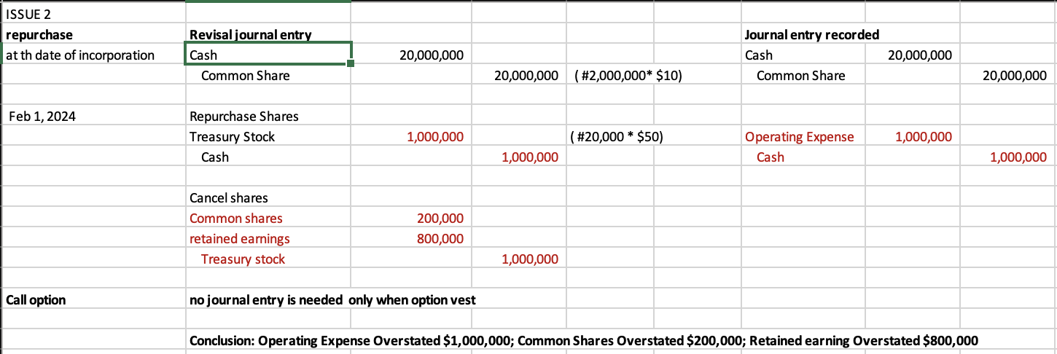

**(Table 2)**

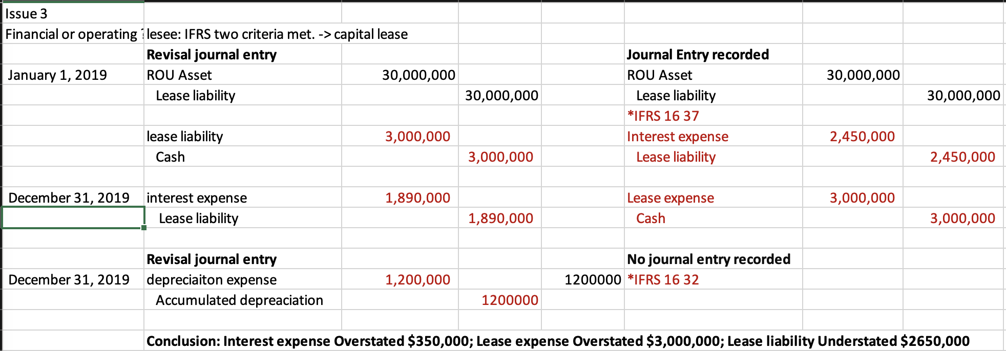

**(Table 3)** 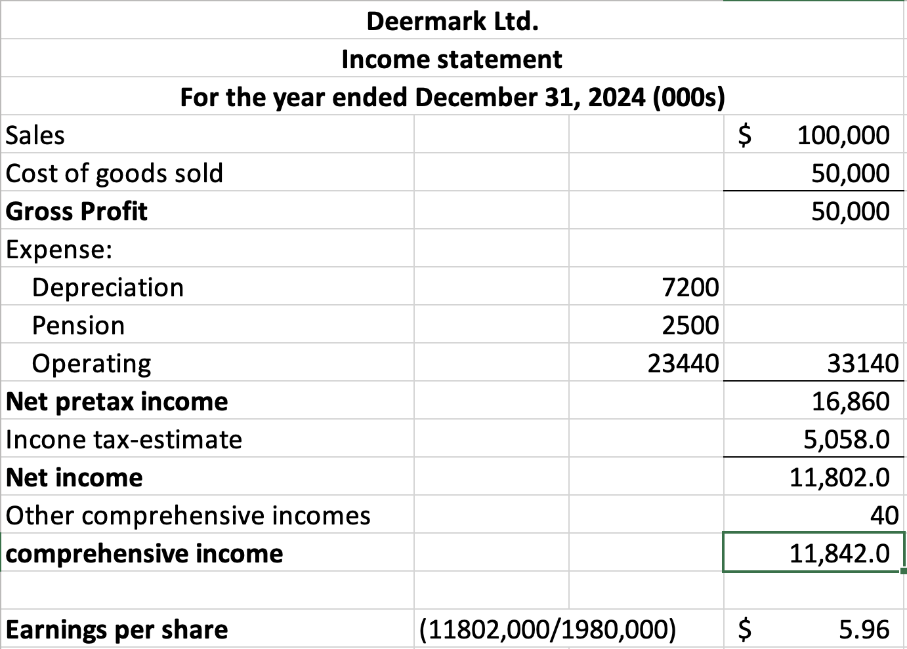

**(Table 4)**

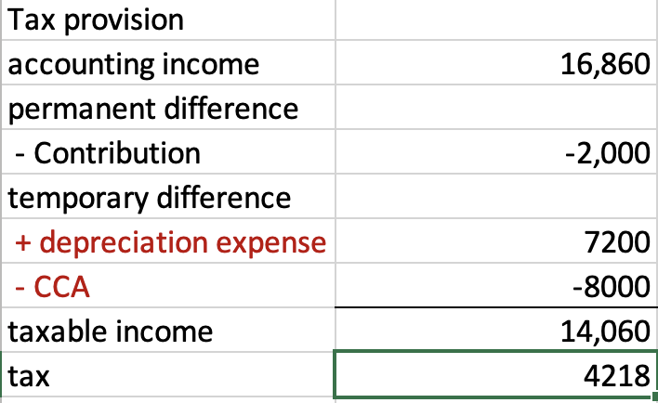

**(Table 5)**